Employee Sentiment and Engagement Analysis – Final Report

# 1. Introduction

This report presents a comprehensive analysis of employee sentiment and engagement using natural language processing (NLP) and predictive modeling techniques. The analysis is based on internal employee message data and aims to assess emotional trends, rank employee engagement, identify flight risk individuals, and forecast sentiment patterns.

# 2. Methodology

We began by cleaning and combining the subject and message body for each email. Using the VADER sentiment analysis tool, each message was labeled as Positive, Neutral, or Negative. Sentiment scores were mapped as +1 (Positive), 0 (Neutral), and -1 (Negative) for quantitative analysis.

Subsequently, we calculated sentiment scores monthly per employee and performed exploratory data analysis (EDA) to visualize trends and distributions. Employees were ranked based on their average sentiment score per month. A flight risk model was developed using a rolling 30-day window to flag employees with 4 or more negative messages. Finally, predictive models were built to analyze sentiment trends using time, message length, and message frequency as features.

# 3. Key EDA Findings

- Sentiment Distribution: Most messages are Neutral or Positive. Negative messages occur less frequently but are concentrated among a few employees.  
- Message Length Patterns: Positive messages tend to be longer, while Neutral messages are typically shorter.  
- Monthly Trends: Some employees show consistent sentiment trends, while others display high variance.

# 4. Scoring and Ranking

Each employee's sentiment score was calculated monthly:  
- Positive = +1, Neutral = 0, Negative = -1  
- Scores were aggregated and averaged per month

To ensure fairness, average score was used instead of total score to eliminate bias from message count variations. Employees were then ranked:  
- Top 3 Positive: highest average sentiment  
- Top 3 Negative: lowest average sentiment  
Ties were broken alphabetically. Rankings were tabulated monthly.

# 5. Flight Risk Identification

Criteria: An employee is flagged as flight risk if they send 4 or more Negative messages within any 30-day rolling window.  
  
Method:  
- Negative messages were filtered and sorted per employee  
- A non-overlapping sliding window approach checked for qualifying message groups  
- Once a window was detected, it was counted and skipped forward

Results:  
- 7 employees were flagged with at least one flight risk event  
- Results include risk start/end dates and event counts

# 6. Predictive Modeling

We conducted three linear regression models to explore sentiment prediction:

Part 1: Individual Trend Prediction  
- One model per employee using month index as the feature  
- R^2 scores were low due to high variance in personal emotional trajectories

Part 2: Message Length vs Sentiment  
- Messages were grouped by length bin (30 characters)  
- Average sentiment per bin was regressed  
- Moderate R^2, with outliers impacting trend

Part 3: Frequency-Based Prediction  
- Used message count, positive count, and negative count to predict average sentiment  
- Strongest R^2, indicating frequency and sentiment composition are good predictors

# 7. Conclusion

- VADER-based labeling provided reliable emotional tagging  
- EDA revealed significant differences in sentiment length, frequency, and variance  
- Average score per month is an effective measure for engagement  
- The rolling 30-day risk model successfully identified employees with sustained negativity  
- Frequency-based modeling offered the most accurate sentiment predictions

# Appendix

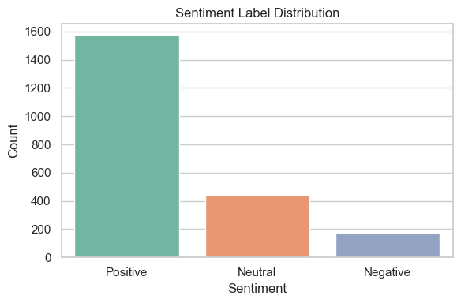

- Figure A: Sentiment Distribution Histogram

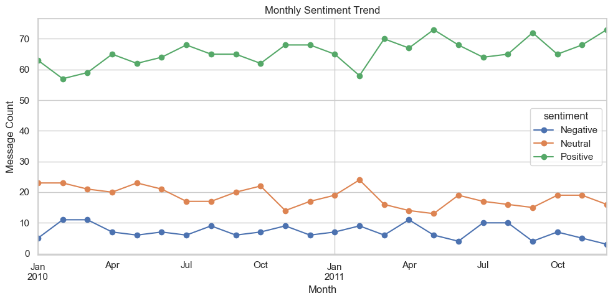  
- Figure B: Monthly Sentimental Trend

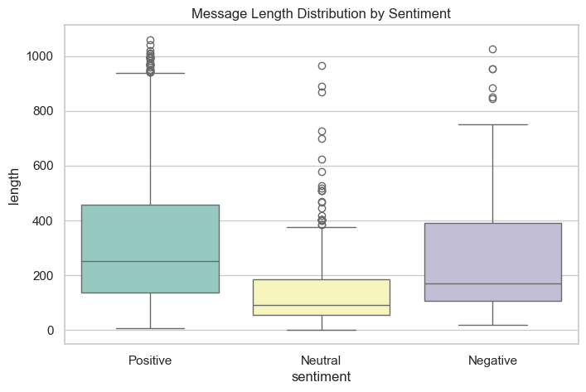  
- Figure C: Message Length Distribution by Sentiment

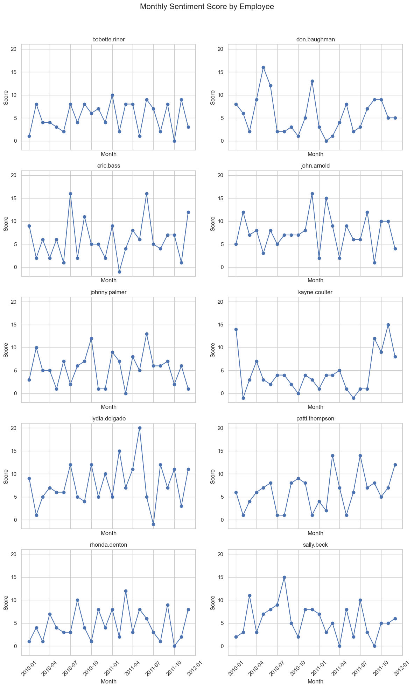  
- Figure D: Monthly Sentiment by Employee

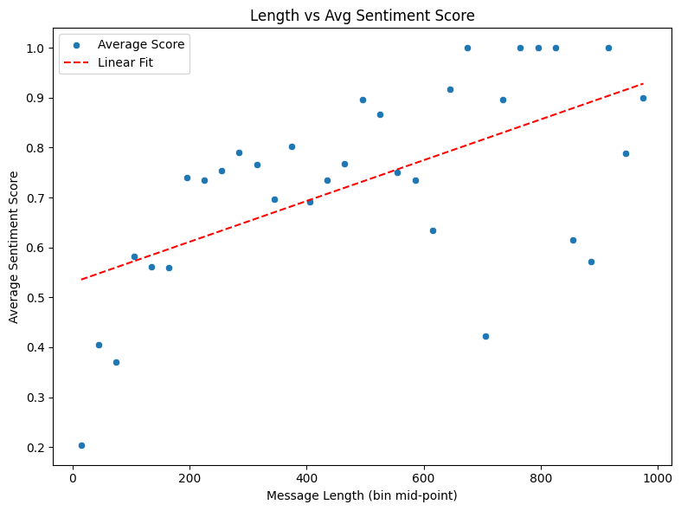  
- Figure E: Length vs Avg Sentiment Score

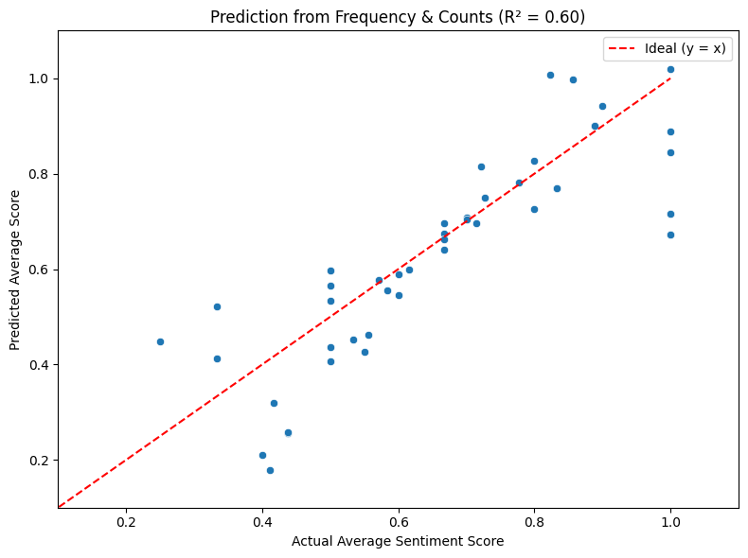  
- Figure F: Prediction from Message Frequency